Fig 1Twoutility functions Ua , Ub as a function of S and T.

Fig. 2

I would like to generate **univariate** Figs for Ua (S) and Ub (1-S), i..e

Each utility function is univariate Gaussian, Ua is centered at S=0 and Ub at S=1.

One Fig. showing Ua and Ub separately as in Fig. 1 above, and another Fig. showing Ua + Ub as in Fig 2 above.

For both Figs, indicate (in bold) a line segment corresponding to shaded area in 2D space, and also for the sum Fig indicate maximum point in green (as in Figs above)

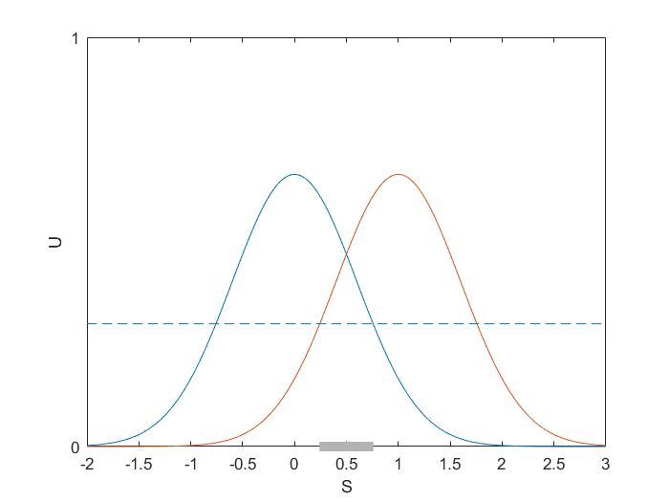

Fig. 3 Two identical utility functions

Fig. 4 Sum of two identical utility functions

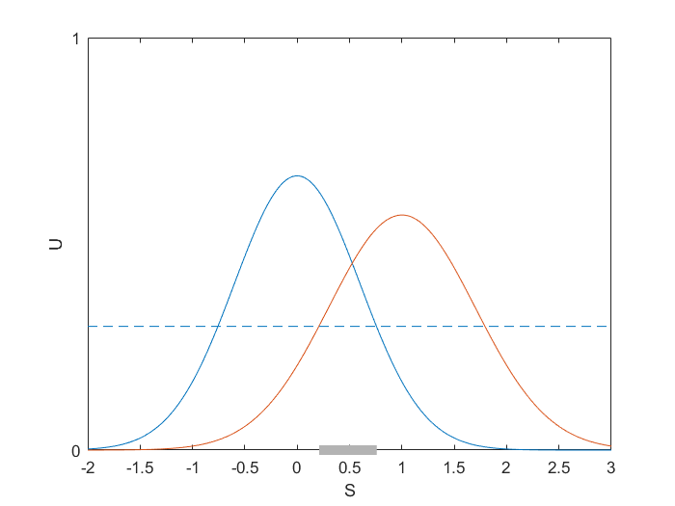

Fig. 5 Two utility functions with different widths

Fig. 6 Sum of two utility functions with different widths

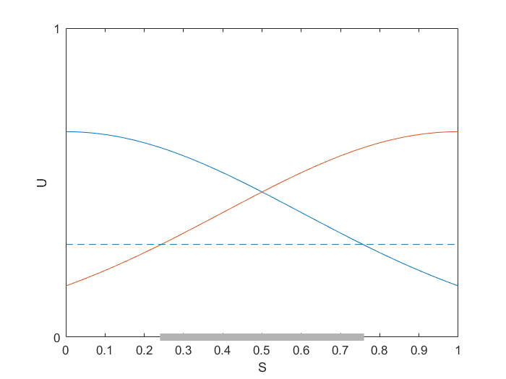

Fig. 7 Two identical utility functions (S = [0 1])

Fig. 8 Sum of two identical utility functions (S = [0 1])

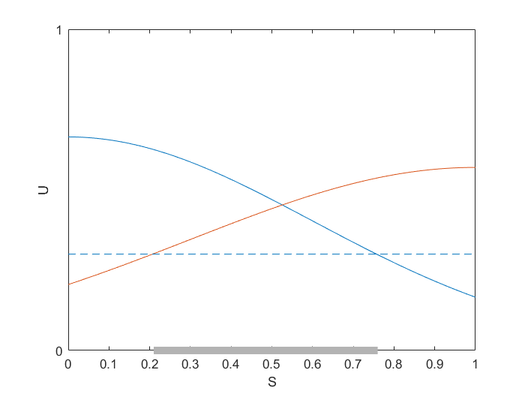

Fig. 9 Two utility functions with different widths (S = [0 1])

Fig. 10 Sum of two utility functions with different widths (S = [0 1])

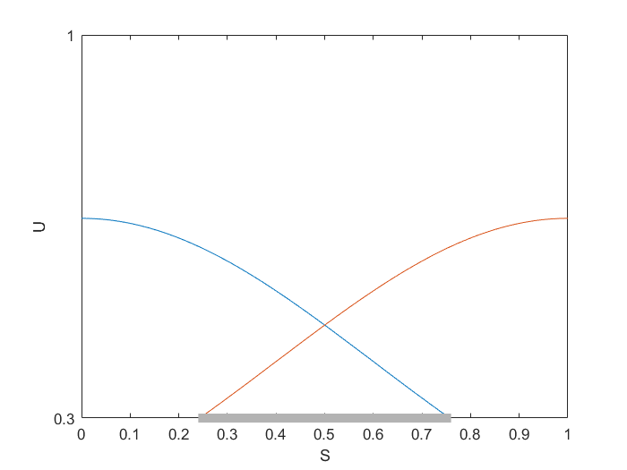

Fig. 7A Two identical utility functions (S = [0 1], U = [0.3 1])

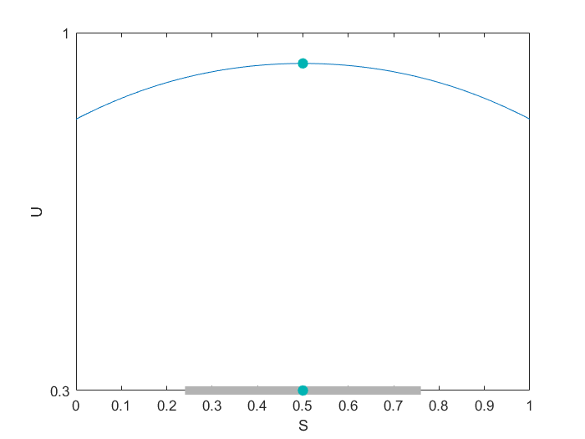

Fig. 8A Sum of two identical utility functions (S = [0 1], U = [0.3 1])

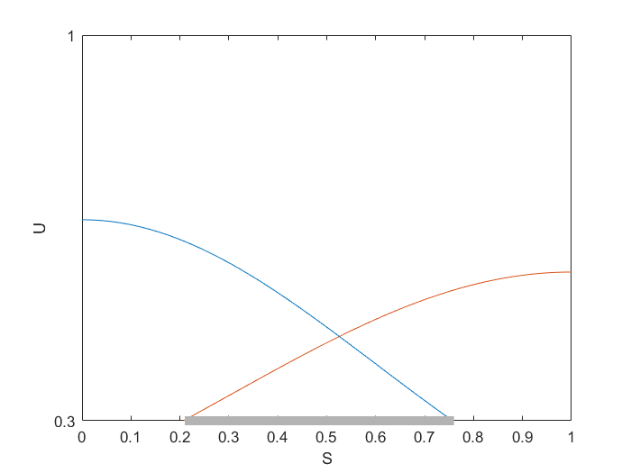

Fig. 9A Two utility functions with different widths (S = [0 1], U = [0.3 1])

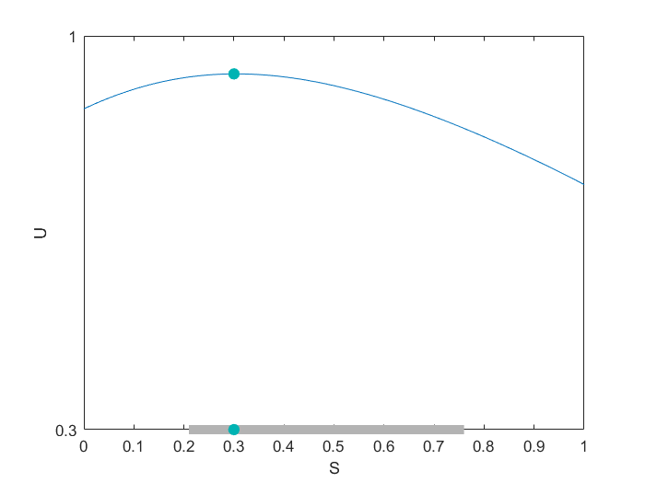

Fig. 10A Sum of two utility functions with different widths (S = [0 1], U = [0.3 1])